CIS41032 - PRACTICAL FOR ADVANCE DATABASE MANAGEMENT SYSTEM
Reg.No : SEU/IS/20/ICT/084
00.
use LibraryDB;

db.libraryBooks.insertMany([
{ "BookID": "B001", "Title": "Introduction to Databases", "Author": "C.J. Date", "Category": "Database", "Copies": 5, "PublishedYear": 2018, "Status": "Available" },
{ "BookID": "B002", "Title": "Learning Python", "Author": "Mark Lutz", "Category": "Programming", "Copies": 2, "PublishedYear": 2019, "Status": "Borrowed" },
{ "BookID": "B003", "Title": "MongoDB Basics", "Author": "Kristina Chodorow", "Category": "Database", "Copies": 8, "PublishedYear": 2020, "Status": "Available" },
{ "BookID": "B004", "Title": "Clean Code", "Author": "Robert C. Martin", "Category": "Programming", "Copies": 4, "PublishedYear": 2008, "Status": "Available" },
{ "BookID": "B005", "Title": "Web Development Handbook", "Author": "Jon Duckett", "Category": "Web", "Copies": 3, "PublishedYear": 2017, "Status": "Borrowed" },
{ "BookID": "B006", "Title": "JavaScript: The Good Parts", "Author": "Douglas Crockford", "Category": "Web", "Copies": 7, "PublishedYear": 2009, "Status": "Available" },
{ "BookID": "B007", "Title": "React Up & Running", "Author": "Stoyan Stefanov", "Category": "Web", "Copies": 1, "PublishedYear": 2021, "Status": "Borrowed" },
{ "BookID": "B008", "Title": "Advanced Java", "Author": "Herbert Schildt", "Category": "Programming", "Copies": 6, "PublishedYear": 2016, "Status": "Available" },
{ "BookID": "B009", "Title": "Cloud Computing Concepts", "Author": "Rajkumar Buyya", "Category": "Cloud", "Copies": 4, "PublishedYear": 2022, "Status": "Borrowed" },
{ "BookID": "B010", "Title": "Node.js in Action", "Author": "Mike Cantelon", "Category": "Programming", "Copies": 3, "PublishedYear": 2015, "Status": "Available" },
{ "BookID": "B011", "Title": "Fundamentals of AI", "Author": "Stuart Russell", "Category": "AI", "Copies": 2, "PublishedYear": 2020, "Status": "Available" },
{ "BookID": "B012", "Title": "Machine Learning Basics", "Author": "Tom Mitchell", "Category": "AI", "Copies": 5, "PublishedYear": 2021, "Status": "Borrowed" }
]);

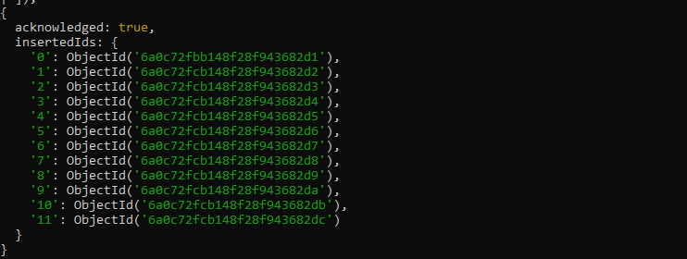

01.
db.libraryBooks.find({ "Category": "Programming" });

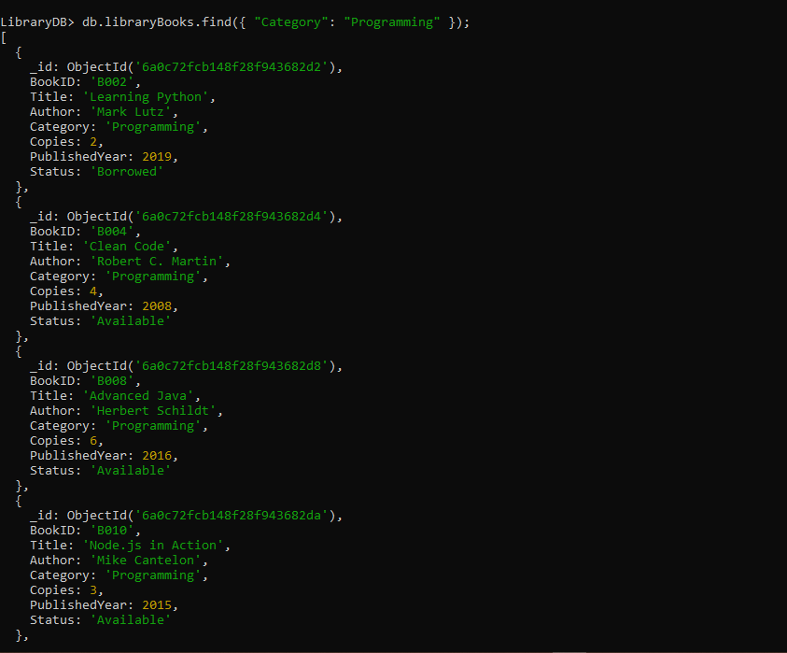

02.
db.libraryBooks.find({ "Copies": { $lt: 4 } });

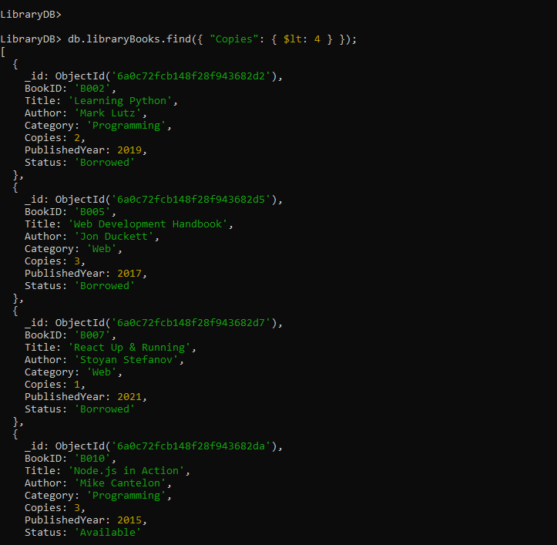

03.
db.libraryBooks.find({
"Status": "Available",
"PublishedYear": { $gt: 2015 }
});

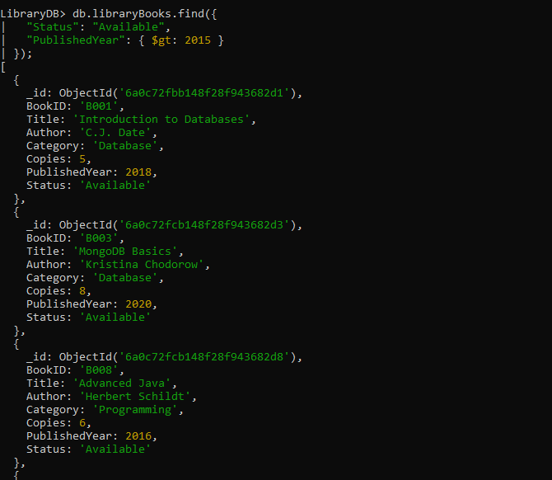

04.
db.libraryBooks.find({ "Title": { $regex: "Basics", $options: "i" } });

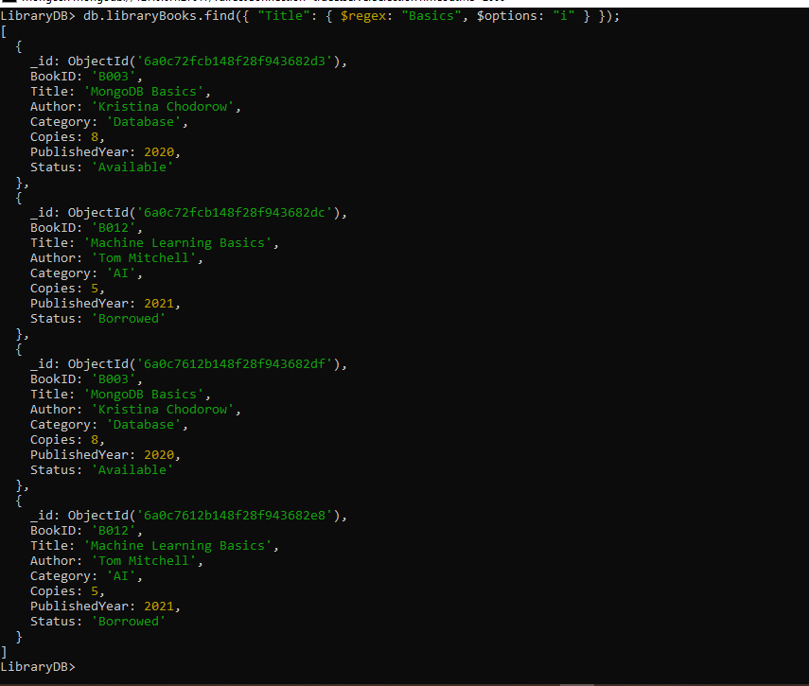

05.
db.libraryBooks.find({
$or: [
{ "PublishedYear": { $lt: 2010 } },
{ "Copies": { $gt: 5 } }
]
});

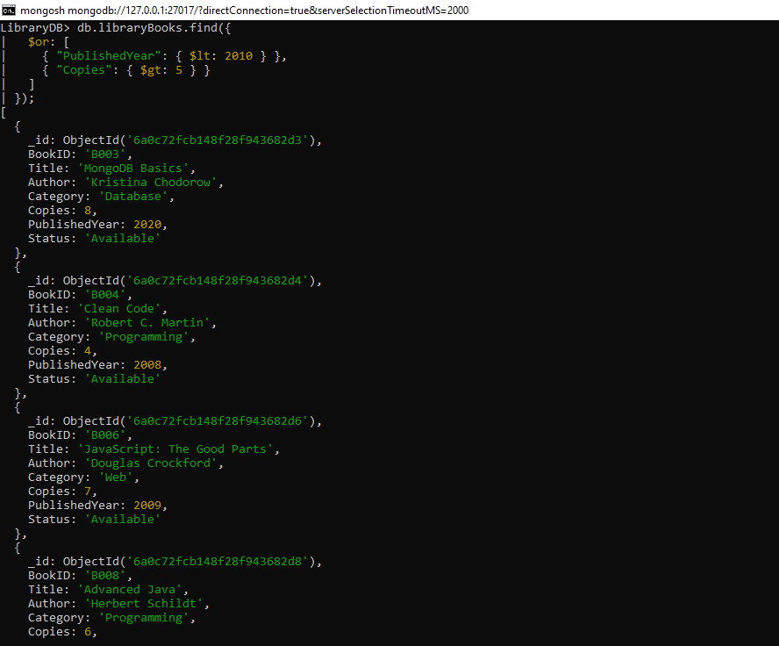

06.
db.libraryBooks.find({ "Category": { $ne: "Web" } });
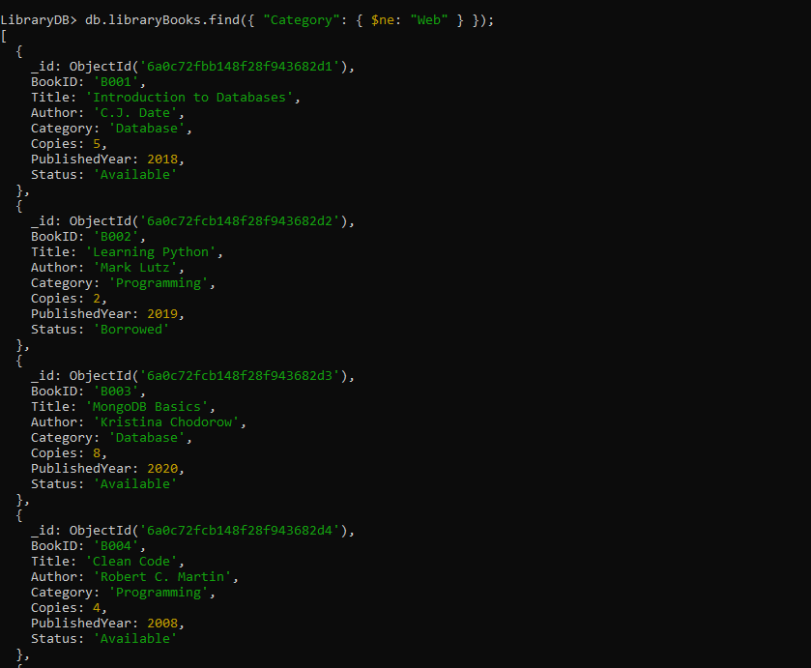

07.
db.libraryBooks.find({ "Author": { $in: ["Mark Lutz", "Robert C. Martin"] } });

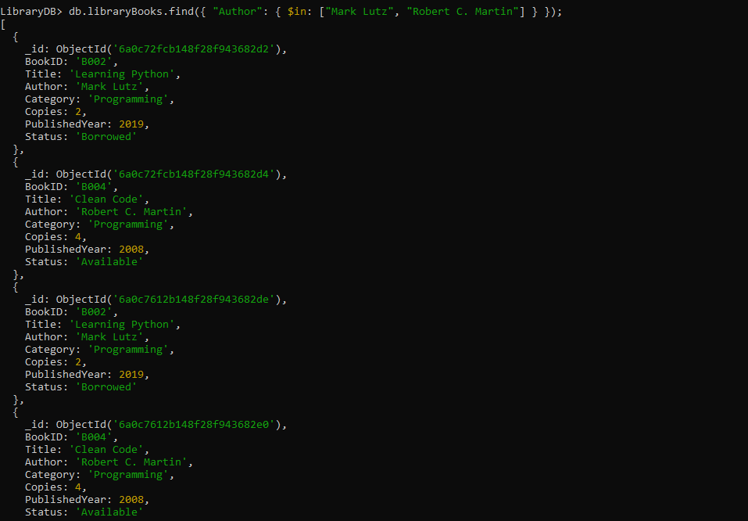

08.
db.libraryBooks.find({
"Status": "Borrowed",
"Copies": { $lt: 3 }
});

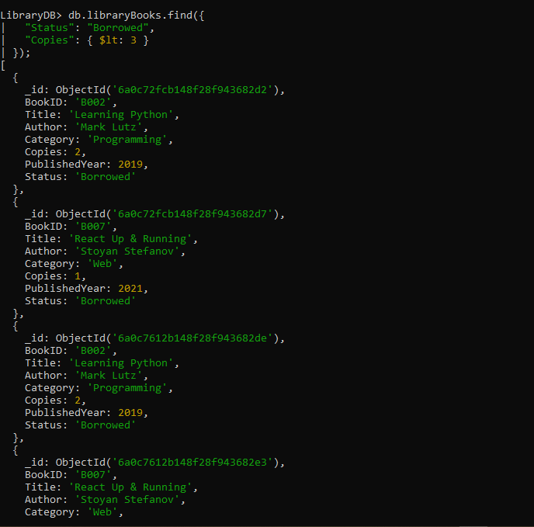

09.
db.libraryBooks.find({
"PublishedYear": { $gte: 2016, $lte: 2020 }
});

